Given numBottles full water bottles, you can exchange numExchange empty water bottles for one full water bottle.

The operation of drinking a full water bottle turns it into an empty bottle.

Return the **maximum** number of water bottles you can drink.

**Example 1:**

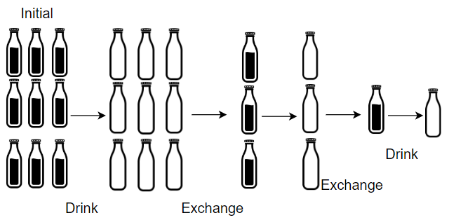

**Input:** numBottles = 9, numExchange = 3

**Output:** 13

**Explanation:** You can exchange 3 empty bottles to get 1 full water bottle.

Number of water bottles you can drink: 9 + 3 + 1 = 13.

**Example 2:**

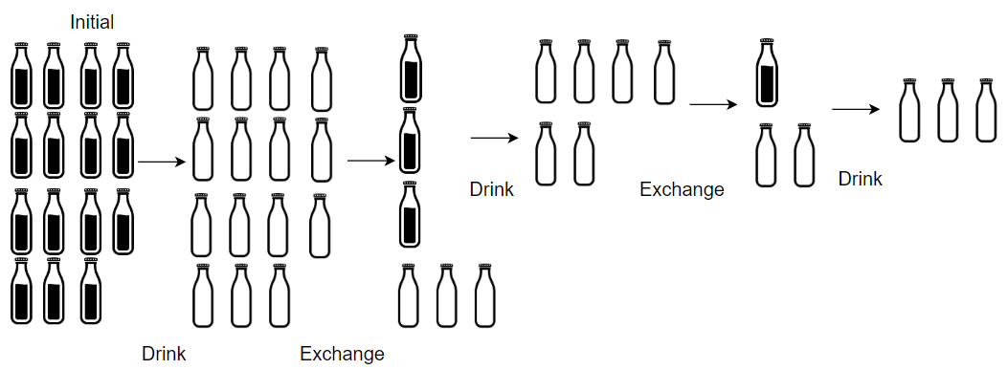

**Input:** numBottles = 15, numExchange = 4

**Output:** 19

**Explanation:** You can exchange 4 empty bottles to get 1 full water bottle.

Number of water bottles you can drink: 15 + 3 + 1 = 19.

**Example 3:**

**Input:** numBottles = 5, numExchange = 5

**Output:** 6

**Example 4:**

**Input:** numBottles = 2, numExchange = 3

**Output:** 2

**Constraints:**

* 1 <= numBottles <= 100
* 2 <= numExchange <= 100